Name: Jay Rajesh Umap

Roll No.: 2205010

Class: SY IT

Div.: CORE 1

1.List of students belonging to IT department

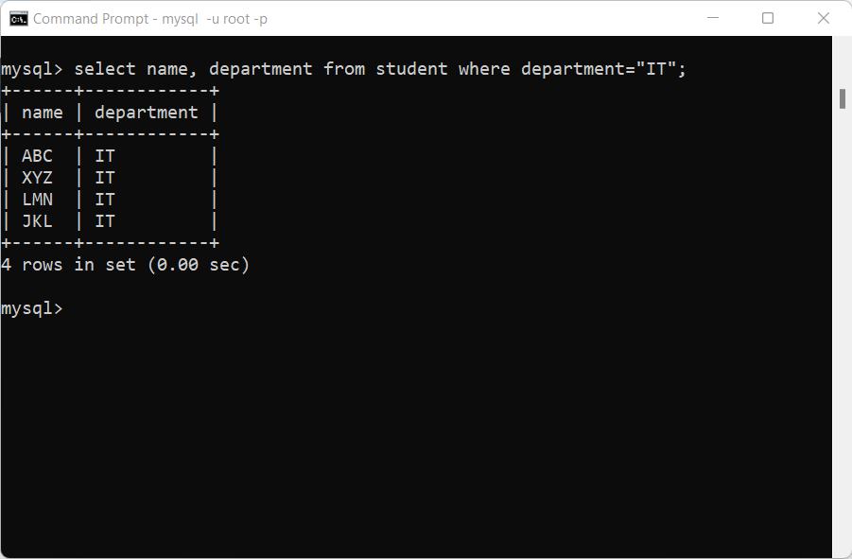

2. Add a Column Category (Computer/Mechanical/Electronic etc.) in Book_master table

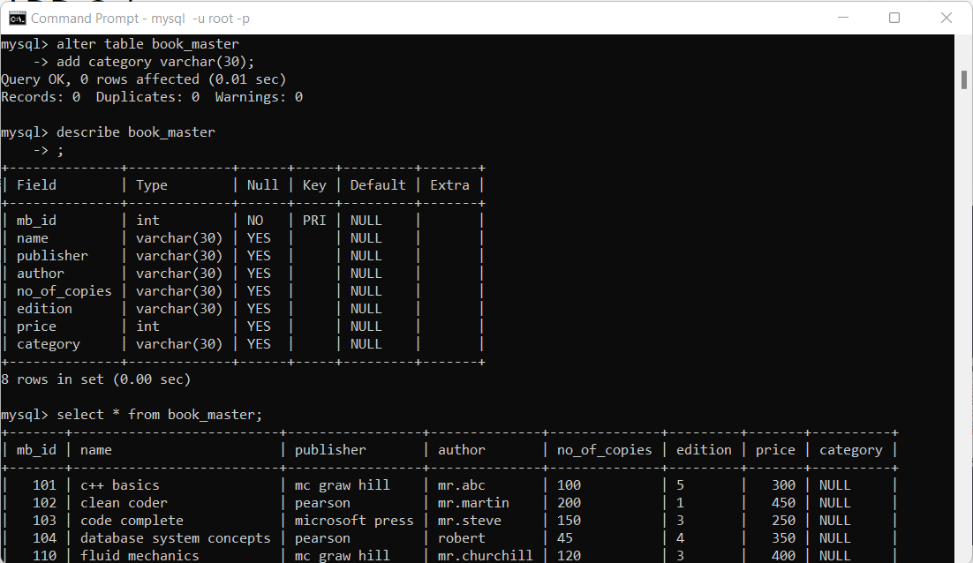

3. Change the Content of Department Column from Null to Appropriate Category.

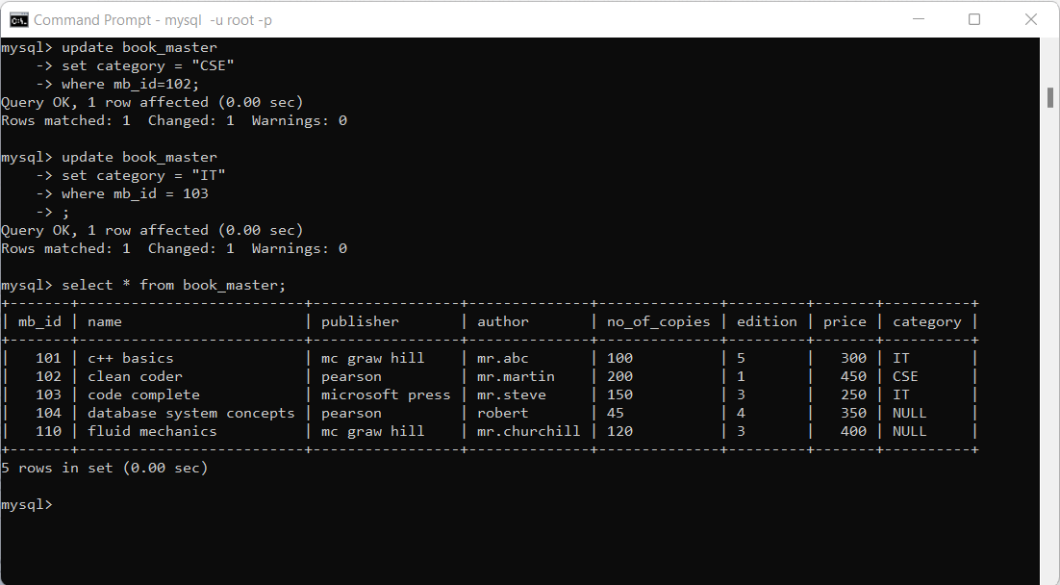

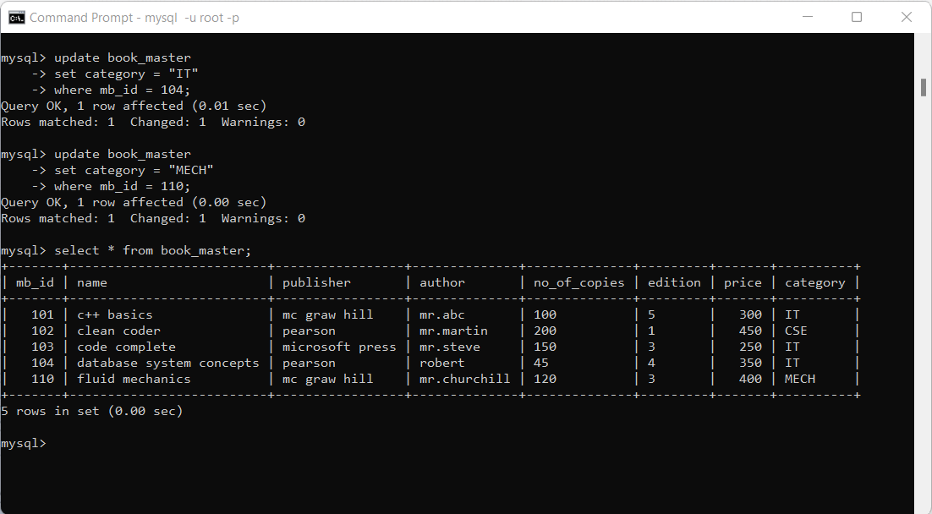

4. Show the Structure of Tables.

Student:

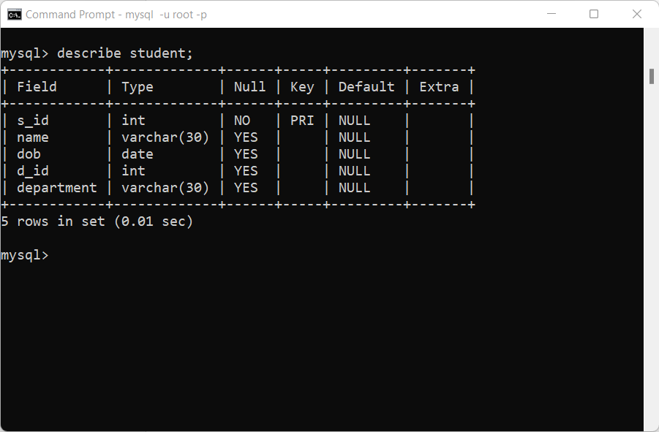

Book_master:

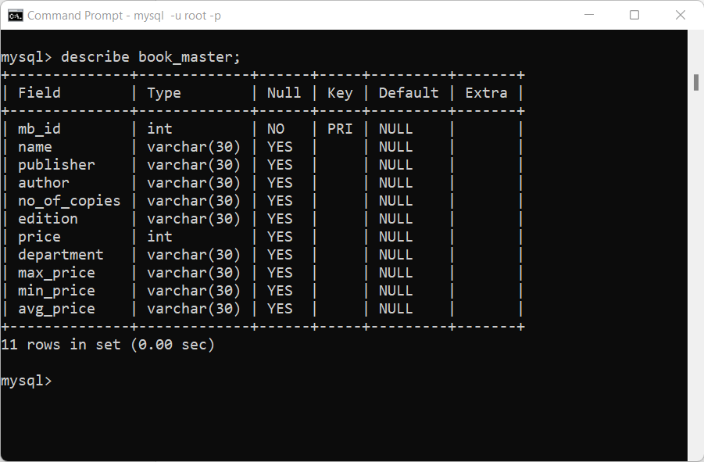

Book_detail:

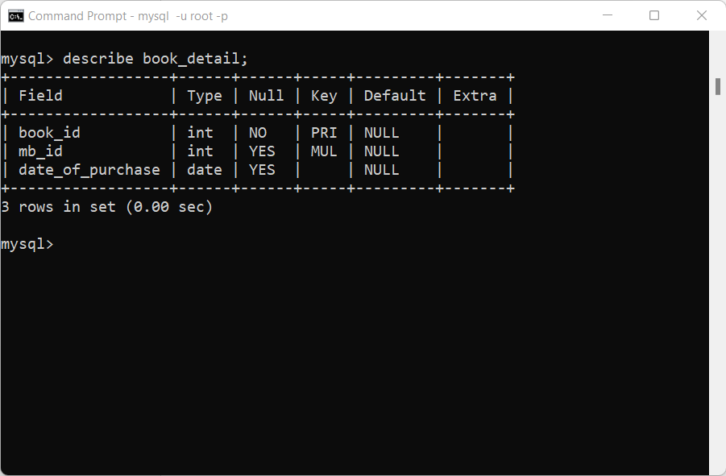

Transaction:

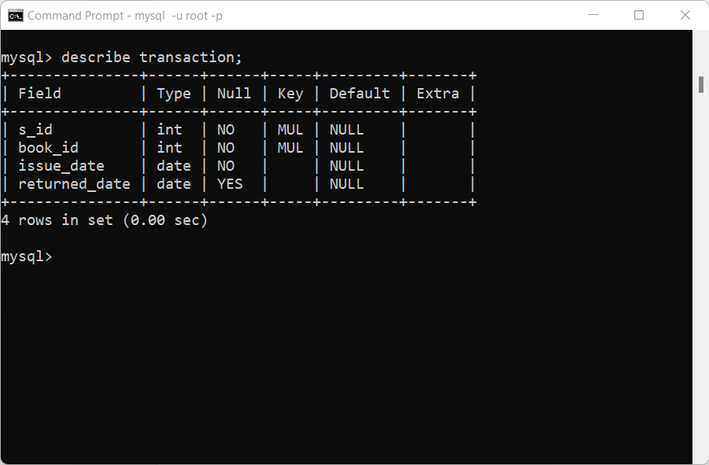

5. List the Names (Title) of the Books and Authors name Belonging to Computer Science.

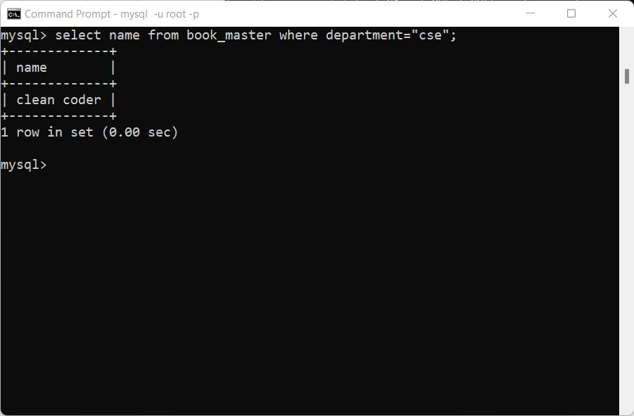

6. List the Name of Books Whose Copies are Less Than 10.

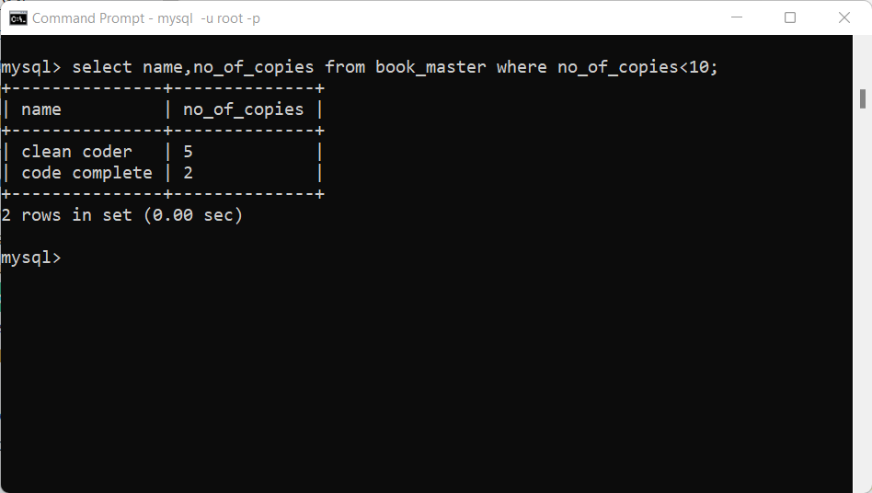

7. List the Student Names whose names either start or end with “N”

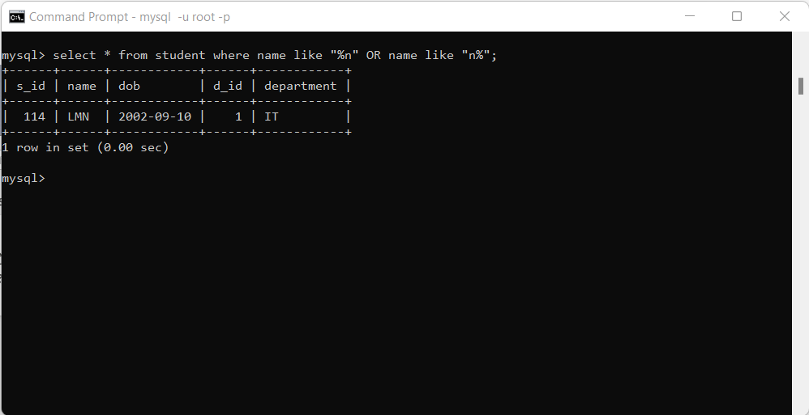

8. List the Book Names whose Names Contain Database.

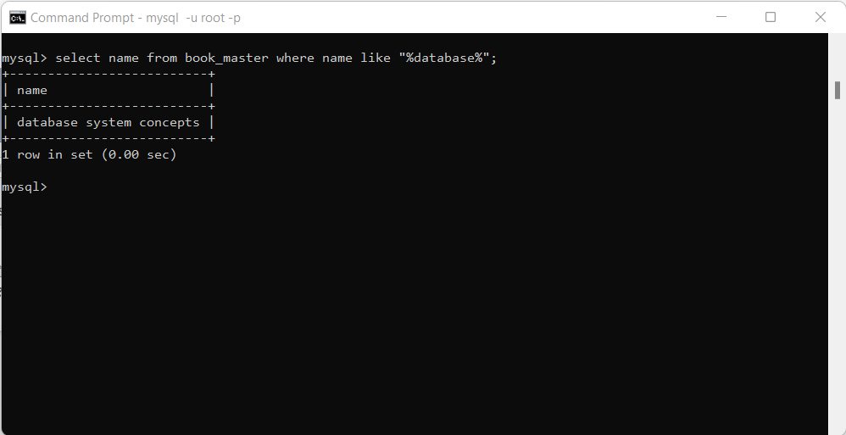

9. What is the Count of Book which are Issued but not Returned.

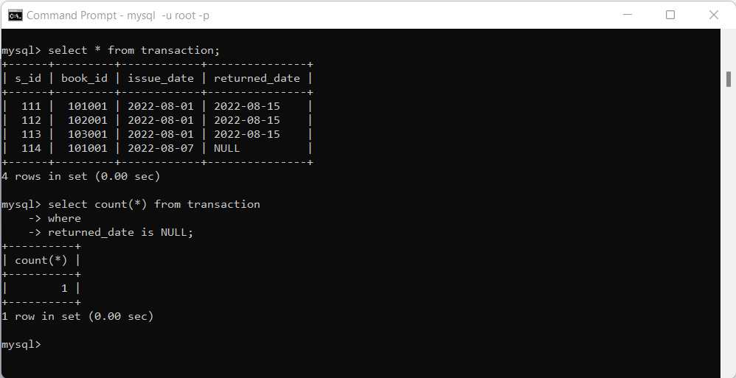

10. List the Maximum, Minimum and Average Price of the books for each Category.

Maximum price:

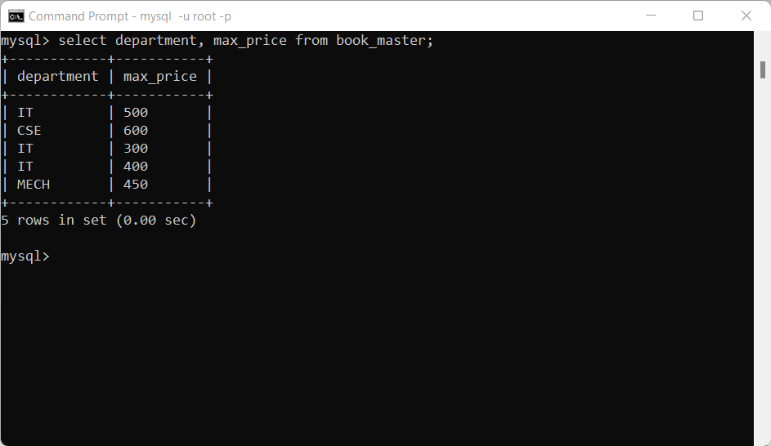

Minimum price:

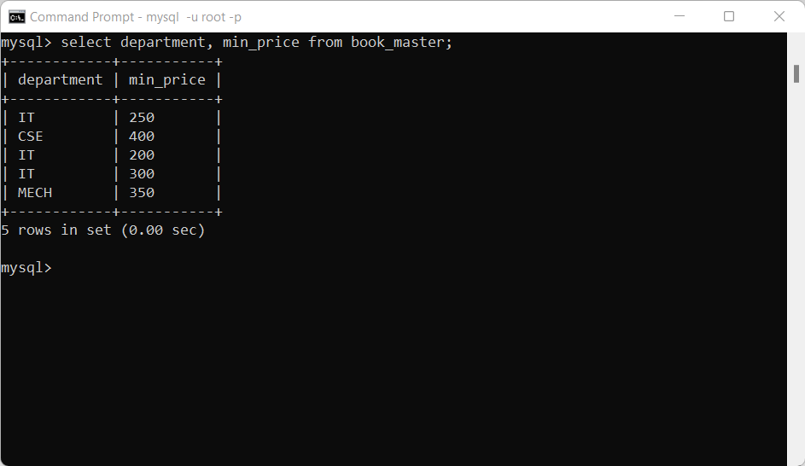

Average price:

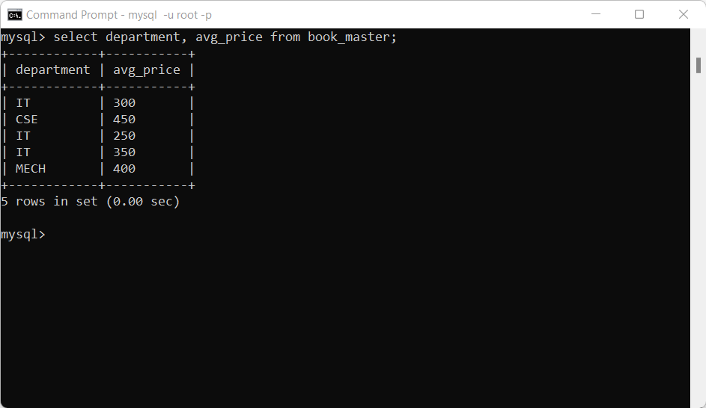

11. List the book names which are Not Returned

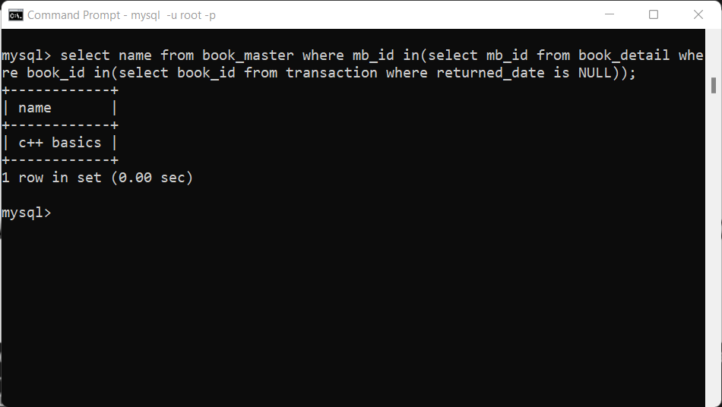

12. List the student Name who have not accessed a Single book from the library.

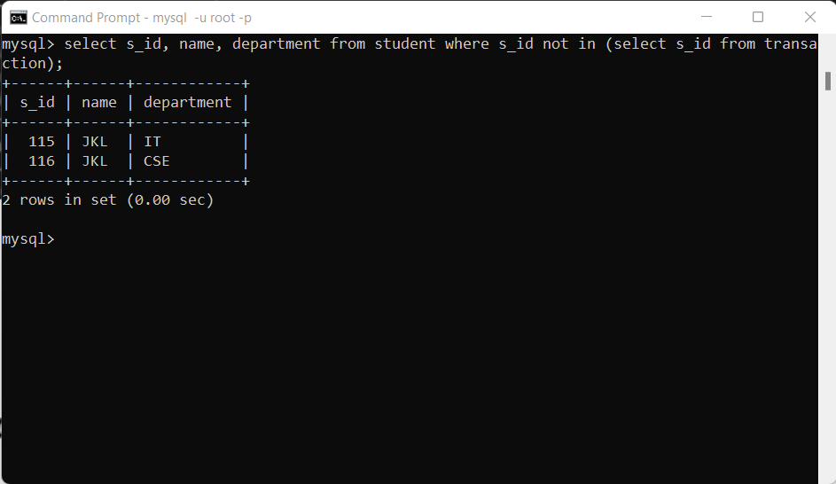

13. Display the Maximum, Minimum and Average Price for the Computer Books.

Maximum:

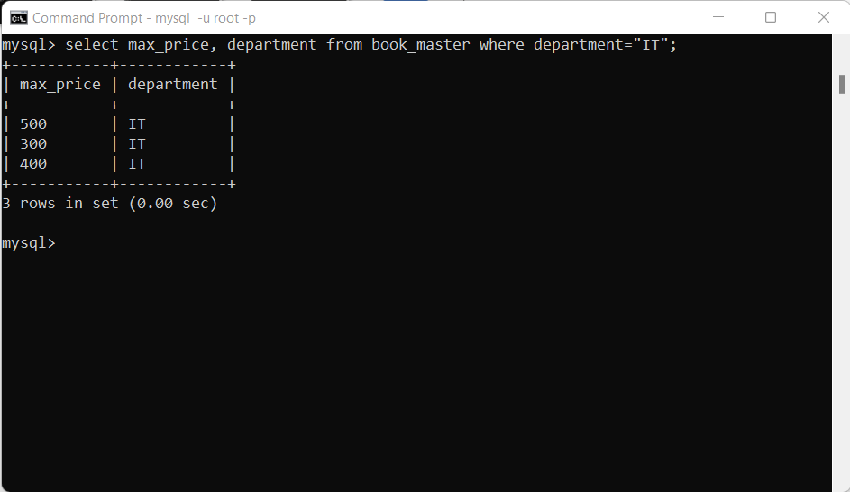

Minimum:

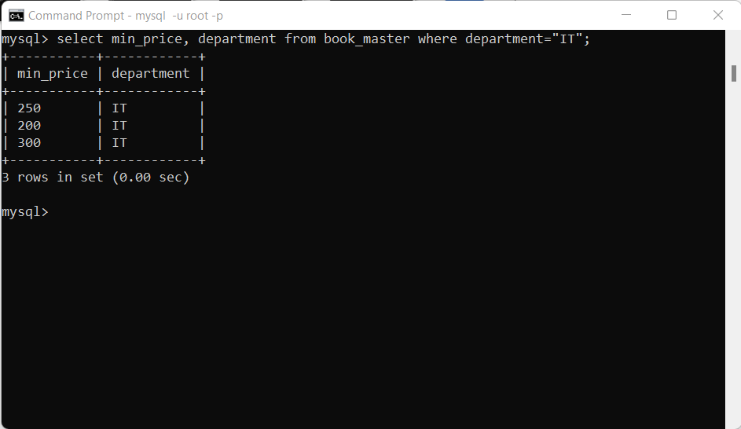

Average:

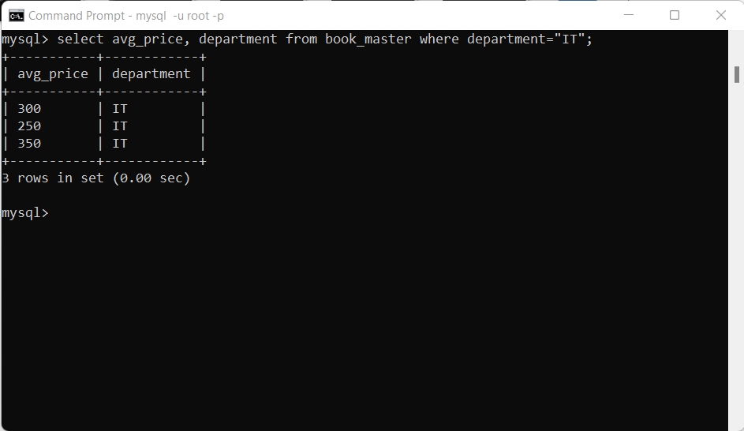

14. Show the Book Names and the Price for in Sorted Order of Book Name

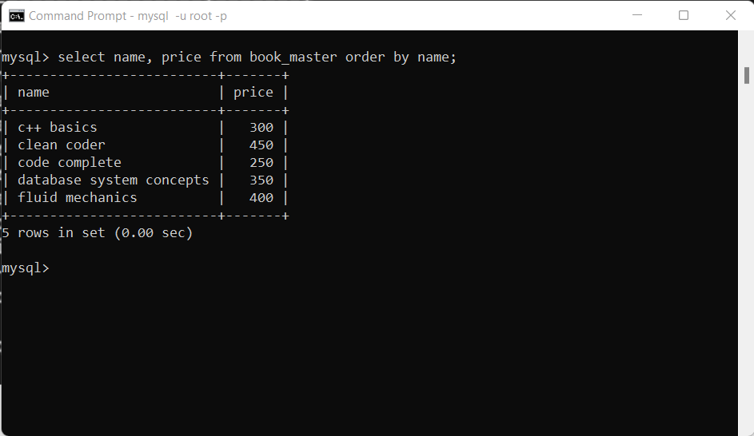

15. List the Names of the Student who has accessed the library books without any duplication

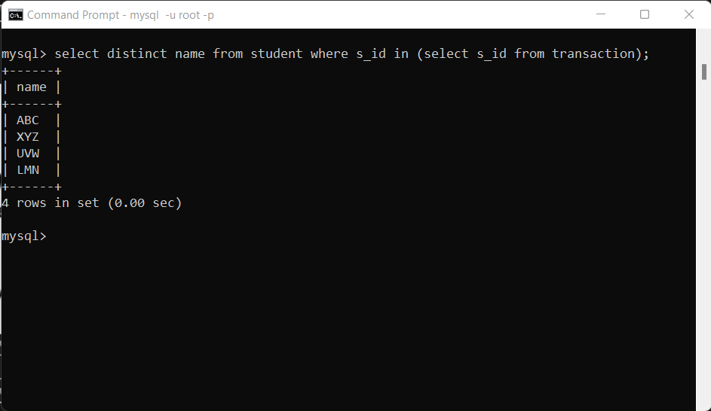

16. Display the book information’s Costlier than the price of “Database system Concepts” Book.

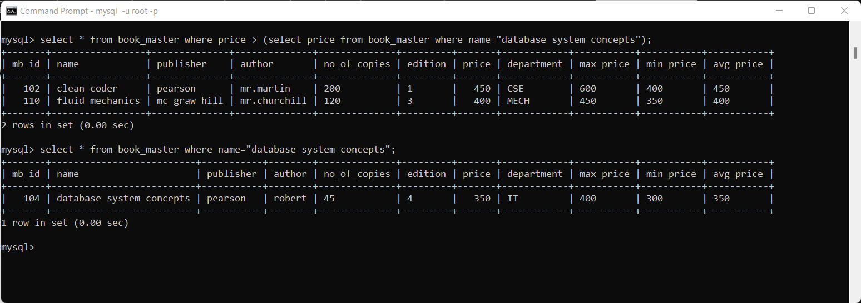

17. List the Category and No of Books in each Category.

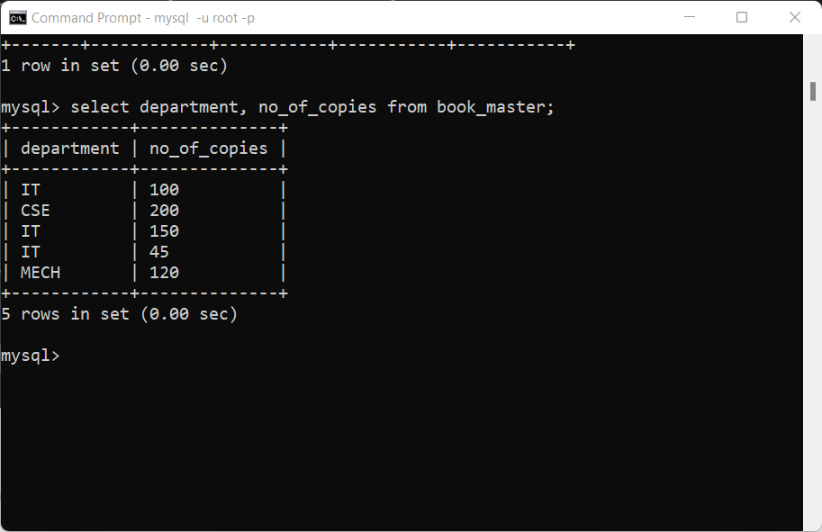

18. List the Names of Books whose Price is in Range of 300-400 Rs

